# **[Demo 11: How to use SmartConfig on Arduino ESP32](http://www.iotsharing.com/2017/05/how-to-use-smartconfig-on-esp32.html)**

**1. Introduction**

In previous demos, we use WiFi class to connect to a WiFi network "WiFi.begin(ssid, password)". Here we use "hard-coded" ssid and password. It is really inconvenient when we bring our ESP32 to another WiFi network, we have to modify ssid and password according to new network, recompile and flash new code. So there is a technique to overcome this called **"SmartConfig"** which was invented by TI. You can refer it here:  
<https://community.particle.io/t/smart-config-the-missing-manual-now-available/442>  
Now this technique was also applied for ESP32. In order to do SmartConfig, you need a smartphone or tablet (Android or iOS) that connected to WiFi network (which you want ESP32 to connect to) and installed a special application. On this application, you just supply the ssid and password of WiFi network so that the application can use, encode them and then broadcast (via UDP) encoded ssid and password (under packet format) over the air. At this moment, ESP32 with a special software in it will capture these packets, decode back ssid and password and use them to connect to Wifi network. After connecting to WiFi ESP32 will use mDNS to multicast a message to the application to notify that it connected to WiFi.  
The source code of special application is supplied by **Espressif**. You can download at:  
[https://github.com/EspressifApp/EsptouchForAndroid  
https://github.com/EspressifApp/EsptouchForIOS](https://www.blogger.com/)  
This application is also available on App Store. You can use it to test SmartConfig feature.  
- For Android, this application is available under name "I**OT_Espressif**" or another application "**ESP8266 SmartConfig**" (this is for ESP8266 but you can use it for ESP32):  
<https://play.google.com/store/apps/details?id=com.cmmakerclub.iot.esptouch>  
<https://play.google.com/store/apps/details?id=com.espressif.iot>  
- For iOS, this application is available under name "**Espressif Esptouch"**:  
<https://itunes.apple.com/us/app/espressif-esptouch/id1071176700?mt=8>

**2. Hardware**

You do not need any extra hardware

**3. Software**

Some functions that are related to SmartConfig feature, also in WiFi class:  
 - WiFi.mode(WIFI_AP_STA): set ESP32 to Station mode (To run SmartConfig it must be set to Station mode)  
- WiFi.beginSmartConfig(): start SmartConfig  
- WiFi.smartConfigDone(): check whether SmartConfig is done or not  
- Let 's make a simple demo for this feature. We use an Android smart phone which installed **"ESP8266 SmartConfig"** and an **ESP32 with SmartConfig code**.

From smartphone (connected to WiFi) do:

Open the application -> **fill ssid and password** and then **press** **Confirm** button.

[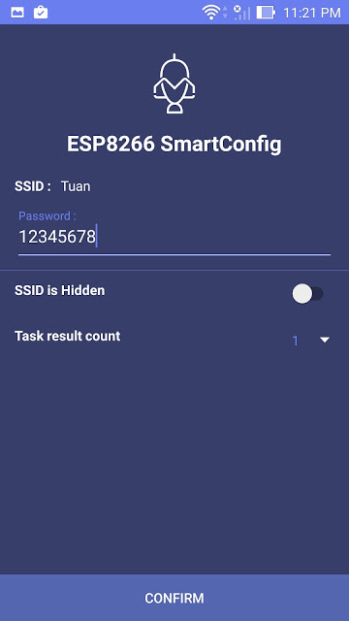](https://1.bp.blogspot.com/-HsHz0KC7XJg/WSFNwYcfU4I/AAAAAAAAD5M/iQ66dvdzD9oEj_HDyV0Wvu_oqhGmWsPhACLcB/s1600/smart1a.jpg)

**Figure: ESP8266 SmartConfig app with Menu**

Create an Arduino project, save as **esp32smartconfig** with code:

|  |
| --- |
| #include "WiFi.h"  void setup() {  Serial.begin(115200);  /* Set ESP32 to WiFi Station mode */  WiFi.mode(WIFI_AP_STA);  /* start SmartConfig */  WiFi.beginSmartConfig();  /* Wait for SmartConfig packet from mobile */  Serial.println("Waiting for SmartConfig.");  while (!WiFi.smartConfigDone()) {  delay(500);  Serial.print(".");  }  Serial.println("");  Serial.println("SmartConfig done.");  /* Wait for WiFi to connect to AP */  Serial.println("Waiting for WiFi");  while (WiFi.status() != WL_CONNECTED) {  delay(500);  Serial.print(".");  }  Serial.println("WiFi Connected.");  Serial.print("IP Address: ");  Serial.println(WiFi.localIP());  }  void loop() {  } |

**4. Result**

[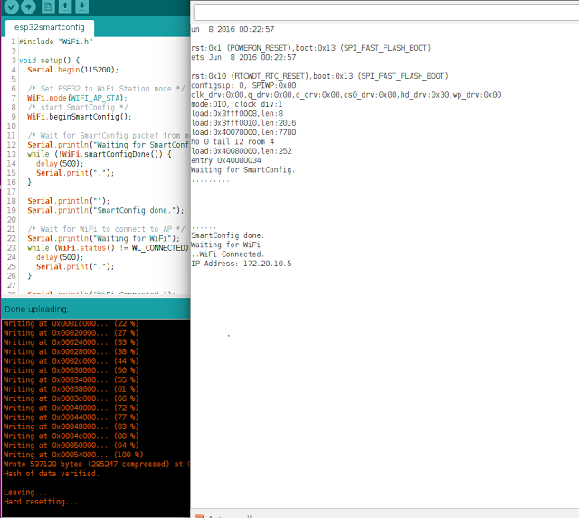](https://2.bp.blogspot.com/-s3Uoc8H9HeQ/WSFOyyLB7jI/AAAAAAAAD5Y/empKc1EkGjMIrFIUm1sK9vqVJ4mnlicdACLcB/s1600/internet16.png)

**Figure: From Terminal SmartConfig done, ESP32 join WIFi network with IP address**

[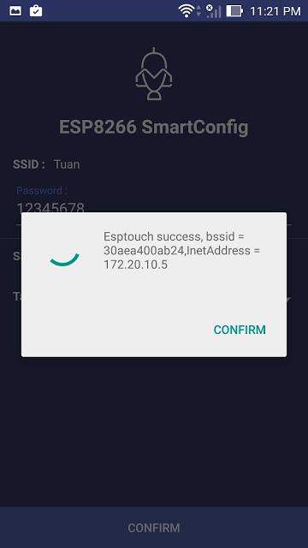](https://3.bp.blogspot.com/-7vy0id6LW0U/WSFPEFH-FDI/AAAAAAAAD5c/57mXxLW3--IPwWFnyG3-mkOgqsCcyT55gCLcB/s1600/smart2a.jpg)

**Figure: From smart phone, ESP connected to WiFi network**